FOUNDATION FOR VIRTUAL AND AUGMENTED REALITY SYSTEMS
Lecture36
Lec-36: Usability requirement gathering and specification
Hello and welcome to the NPTEL MOOCs course on Foundations for Virtual and Augmented Reality Systems. So, we are discussing requirement gathering for end users for our XR systems, and we will continue our discussion in this part of the lecture as well. So, earlier we talked about the importance of gathering end user requirements. which is to ensure usability of the system, which is a very important concern when we are talking about XR systems as these are part of interactive systems. We also started our discussion on a method of usability requirement gathering that is called contextual inquiry.
So, we are going to continue our discussion on contextual inquiry. So, earlier we have learned what contextual inquiry is, that is to observe users in their natural work setting, observe targeted groups of users or specified groups of users in their natural work setting to understand how they behave and what they do. Now let us see what the different ways contextual inquiry can be performed are. So there are broadly two ways for performing contextual inquiry.
One is the active mode. In this mode, the observer or the person who is performing the contextual inquiry is physically present in the environment where the users are doing their tasks. There is another passive mode; here user activities are recorded or videotaped and So, there is no observer as such, but the activities are recorded and then observed later by the observer.
If there are some issues, those can be clarified through interaction with the users. One important thing here is that during the inquiry, the observer should act as an apprentice, and treat the users as masters. So, this is called the master apprentice model. The purpose is to learn the user behavior, not to teach users how to behave.
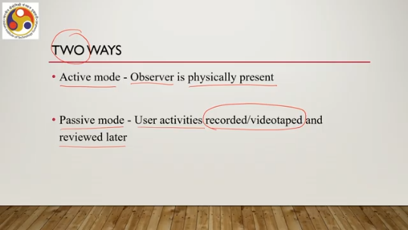
So, it is not easy. We often get this behavioral trait that whenever somebody is doing something, we often get the urge to tell the user, okay, do not do it in this way, do it in that way, that will be better for you. That type of advisory is not desirable. In fact, these are prohibited when you are trying to perform a genuine contextual inquiry.
So, ideally you should always assume that you are the learner and the users are the teachers. So, they are teaching you how they behave and how typically users would be behaving in a given context and you will learn that behavior from them rather than trying to teach them how to behave. So, that is about different categories. Now, let us talk about the stages of the contextual inquiry.
So there are five stages. These stages are basically a systematic way of carrying out the inquiry process. First is plan, then initiate, execute, close, and reflect. So the inquiry starts with the plan stage. It goes to the initiate stage, then the actual inquiry takes place in the execute stage.
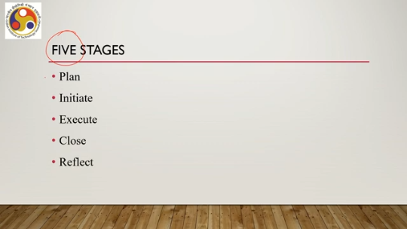
Then it is closed, and then finally reflect means analyzing the data. So in the plan stage, what are the things to do typically? Plan, as the name suggests, means planning the activities. So, we first start with identification of the goals of observation, what we are trying to observe. That needs to be first identified.
Otherwise, if we directly reach there, reach into the workplace, and try to start observing, then we will be confused about what to actually observe. So, first you plan for what exactly we are trying to observe. The second part is gathering knowledge about the task domain. So, what kind of task domain, how the domain is organized, all these things need to be known. Also, plan for arrangements for recording observations if required, or noting down observations, how to do that; all these things need to be planned.
An essential part of the planning is the identification of the users, and the date, time, and place of the observation. Certainly this is one of the most essential components of the plan stage and it always helps to have a script of the procedure and rehearse the script so that on the day of observation it goes as per plan. So scripting of the procedure always helps.
In the initiate stage, that is the second stage, We should contact the authorities for permissions, all necessary permissions, because we will be observing the employees in their work setting. And open communication with the end users to remove their anxieties. So, end users often believe that these observations may lead to something bad for them. So, we need to remove those anxieties so that they can behave naturally in their workplace.
Obtaining permission is also very important because you are going to observe them in their workplace. So, all necessary permissions from relevant authorities must be obtained beforehand. The execute test stage is the one where we actually perform the observation. So, performing observations and recording data takes place in the execute stage. In the close stage,
ideally we should convey our gratitude by sending thank you notes to the users including the authorities maybe. Why? Because in the future you may need to conduct such activities again or some subsequent testing activities maybe usability testing activities where such users may be useful. So, it is always a good idea to formally close by sending thank you notes or some sort of message conveying how they helped you and how grateful you are for the service provided by them.
So, these types of things turn out to be quite useful in the future. Finally, comes the reflect stage. In this stage, the observer or the experimental team analyzes the data which has been collected during the execute stage and identifies the design goals. Now, this is not an easy stage, this is not a very easy thing to do. Because there can be lots of data.
So data are essentially the kind of notes you are taking or the kind of things you are doing. So this amount of data can be huge and sorting them, trying to find patterns from them, trying to find goals from them is not easy. You can do it manually of course, entirely based on your skill. However, there are some tools and techniques available which often help. One such useful technique is called the affinity diagram method,
which is a way to arrange the data so as to find out a pattern from the data easily, which leads to the design specification of the design goals. So, let us try to have a quick look at the affinity diagram method. what it is and how it can be used. Now, when we talk about this affinity diagram method, this is essentially a method to analyze the data collected through contextual inquiry. It consists of five steps.
Generate ideas, step number one. Display ideas, two. Sort ideas into groups, step number three. Create the group header or provide some names, identifiers to the group, and finally draw the finished diagram. So, these are the five steps of the affinity diagram method.
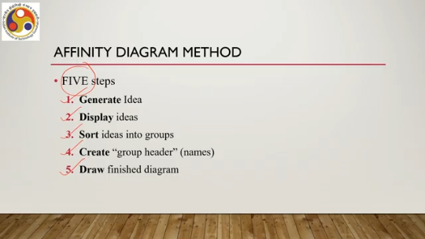
Let us try to understand these five steps in terms of one example. Let us assume that we are building a class note-taking application. So, for the students typically, when they attend class, there will be a mobile app using which they can take notes in class. So, this system is focusing primarily on the needs of college-going students.
So, let us assume that we have performed a contextual inquiry. And we have gathered some data which is supposed to be usability requirements through the contextual inquiry. Now, in order to compare or to identify the specific requirements, we used three tools during the study to observe the behavior and gather requirements. One is physical note-taking, which is typically on pen and paper when a student takes notes, the traditional method.
Then there is one app notion: a web application and Xournal++ and desktop software. So we collected data assuming that the users are using either of these methods and we noted their behavior. So, the observations during the contextual inquiry were noted down and subsequently analyzed using the five stages of the affinity diagram method. Now, step 1 was to generate ideas and step 2 was to display the ideas. So, let us combine them together to see what they mean: generate and display the ideas.
So idea generated: multi-level organization of notes not possible. Another idea generated: freehand drawing is not accurate. Third idea: navigation between different topics is cumbersome. Fourth: content relocation not possible in physical mode. Fifth: difficult to search keywords in notes.
Cannot insert any images, another idea. Erasing contents is a daunting task. Sorting lectures by date is torturous. Incorporating mathematical symbols is not supported. One thing to note here is that these are observations
when the users are using either of the three tools. It is not that using the same tools, all these observations were generated. So, it is a mix of observations for all three tools. Now, these are ideas. Individually, they are ideas, and when they are shown this way, that is displaying the ideas.
There are many such ideas, such as text formatting should be handy, and so on. Organization of course-wise notes is difficult, and so on. Now, that was a rough idea generation, and we can display it this way. As you can see, idea 1, 2, 3, 4, 5, 6, 7, 8, 9, 10, 11, 12, 13, 14, 15, 16, 17, 18, 19. A total of 19 ideas were generated through the inquiry method and displayed in this manner.
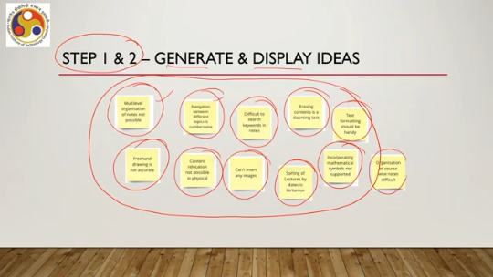
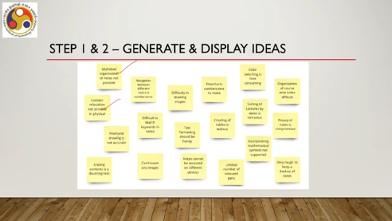
Now, the thing is they may look random. Our objective is to Find out some pattern among these ideas so that from them meaningful conclusions can be drawn. So, we need to go to the next stage, which is step 3: sorting of the ideas into groups. So, groups means essentially we are trying to identify some patterns among the ideas so that similar
ideas with similar patterns can be sorted into a single group. How can we do that? Say, for example, these two ideas: multi-level organization of notes not possible and sorting of lectures by dates is torturous and also organization of course-wise notes difficult. These can be similar. All of these refer to organization of the
notes then navigation between different topics and difficult to search keywords both refer to navigating the notes so they can be similar similarly content relocation not possible and erasing content is a daunting task so content management can be another common idea relating the two So, in that way, we can sort them into groups. Now, once those are sorted, in step 4, we provide a header, that is, provide a name for the pattern which binds multiple ideas. So, that is part of step 4.
See, for example, navigation in notebook. that can be the header under which these different ideas such as sorting of notes by date is torturous, multi-level organization of notes not possible, organization of course, course wise notes difficult, all these things can be put under the header navigation of any navigation in notebook. So, this is the header part. Similarly, Navigation in notes can be another header.
So, one is navigation in notebook, the other one is navigation within a note in the notebook. So, this header can combine ideas such as: difficult to search keywords in notes and navigation between different topics is cumbersome. Another can be note organization, the third header, under which can come the ideas such as: erasing contents is a daunting task, content relocation not possible in physical mode. So, one thing to be noted here is that the data is essentially the notes taken by the observers while observing the behavior. It is anyway kind of note taken by the observer.
So, once those notes are taken, each note is called an idea when we are following the affinity diagram. So, ideas are generated means notes taken, and then maybe when a note is taken during observation, that may be refined with better language in subsequent processing. So, idea generation refers to the final note That is taken by the observer, and then once those are put together in a place, it can be a wall, it can be a board, anything that is called the display. So, stage 1 and 2 refer to idea generation and display.
Then these notes are moved around so that they fall into a certain pattern, which we are calling sorting into groups with a pattern defining the members of each group. Then what we are doing is assigning some header to the groups. Now, this header is essentially referring to the pattern which binds the ideas within a group. So, navigation in notebook, navigation in notes. or note organization, all these are headers.
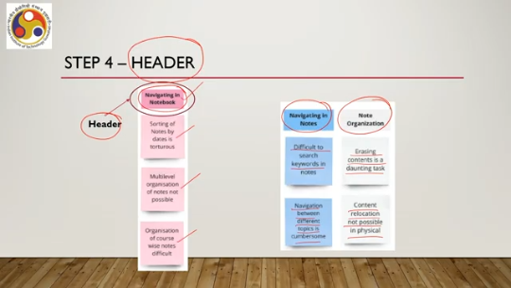
Note that these were not there in the initial ideas, but this came after the ideas were gone through, ideas were understood, ideas were moved around to organize. So, once the organization is done, then only this header business comes into the picture. So, that is step 4. Final drawing is essentially sorting all the ideas into groups. Say for example, navigating in notebooks, media content, navigating in notes, note organization, text formatting, storage and privacy.
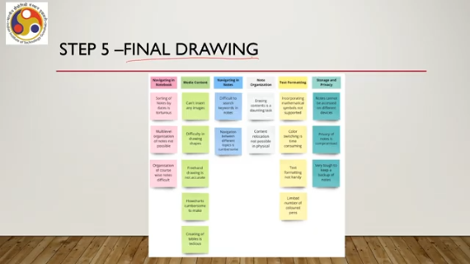
These six can be the header part. And we can see that all the notes that we have taken we can organize them neatly under the six headers. Say navigation in notebook comprises three ideas or notes. Media content comprises five ideas. Navigation in note two ideas.
Note organization again two ideas. Text formatting, 4 ideas. Finally, storage and privacy, 3 ideas. So, essentially the total 19 ideas that we have seen earlier, we can organize into these 6 groups. The number of ideas in each group can vary significantly.
Now, as you can understand while observing we take notes, but later on, repositioning or sorting the notes under clear headers is the most challenging task which we need to do here for further analysis the data or usage of the data. So, after that final drawing, what we do is reflection. Reflection means what to do with the data.
So, we can come up with a set of design recommendations based on the data. In our specific example about note-taking application based on the six groups, we can say that for correcting mistakes, there should be a provision to erase content. This would help in keeping the notes neat and tidy. So, this guideline, we can call it a guideline or recommendation.
Now, we can, even without Conducting contextual inquiry, we can come up with guidelines, but those guidelines will not ensure that we are actually taking into account the users' needs and expectations. When we are performing the inquiry, we are analyzing the data collected and then coming to these guidelines. We are sure that this is going to take care of the users' needs and expectations, so that is the difference between uninformed design choice and informed design choice, where the information comes through methods such as contextual inquiry.
Now, it may be noted here that at this stage, we are not talking about how to do that, how to ensure that this erase facility is there. Rather, our focus is on what we need to do to make it usable. So, this is the requirement. This is not a prescription for implementation. This is, or rather, how to implement that requirement is not specified here.
Instead, we are only bothered about the requirement, identifying the requirement. So, on reflection, let us delve a little deeper. Once we collect the data through CI, we analyze and reflect. What is the outcome? So far, in the previous part, we have seen that we can come up with some design recommendations or guidelines.
But is it the only outcome possible? Only the guidelines? Is it the only outcome? Let us see one more example. The calendar app.
We have earlier seen the calendar app. Now, we are interested in building the app. It is meant for the students mainly to help in their various academic activities. We have already introduced, got introduced to that application earlier. Let us try to find out the requirements to build this app and also specify those so that it is easier to implement.
So, earlier we talked about guidelines, but also we mentioned that this is just the requirement, not how to implement it. Now let us see from the guidelines how we can specify them so that it is easier to implement with respect to this second example. So, usability requirements for the calendar app: we performed a contextual inquiry to get the usability requirements. The five stages we followed, namely: plan, planned the process, initiated the process, executed or collected the data, closed with thank you notes and finally reflect using the affinity diagram method.
So, we followed the affinity diagram method to perform the data analysis or the reflect stage. Now, again affinity diagram comprises of the five stages just to quickly recap, generate idea, display idea, sort, create, group header, and finally draw the finished diagram, which is the final stage. Now, here let us assume for the sake of simplicity in the discussion that we have performed the CI with few students. They used paper based desktop and mobile calendars for academic activities only.
Observations are made and noted down which are our ideas. Those are noted down using sticky notes. And finally, affinity diagram created for analysis. So, step 1 and 2 generate and display ideas. These are the ideas.
So, essentially 1, 2, 3, 4, 5, 6, 7, 7 ideas. As an example, we are showing 7 ideas generated. used by all to set reminders; 4 out of 5 used to check upcoming deadlines; 4 out of 5 used to check date and then check timetable for the device; 4 out of 5 used calendar to check meeting dates; 3 out of 5 used to check meeting schedule on a particular day; all used to check lecture schedule on a particular day; and 3 out of 5 used mobile app to check day and date and set reminder for assignment submission.
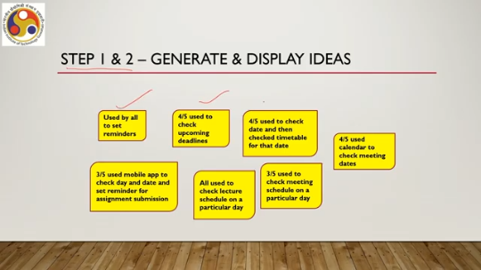
Then we went to step three, that is grouping. Now we can organize them as used by all to set reminders and three out of five used mobile app to check day and date and set reminder for assignment submission. These two are related to reminder setting. We can group them. Four out of five used to check upcoming deadlines.
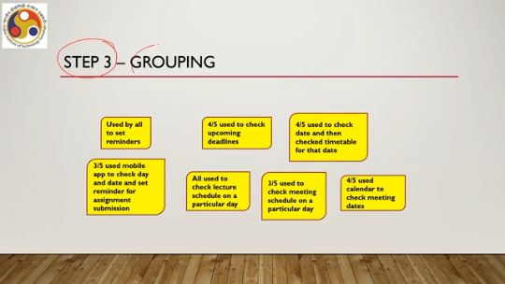
All used to check lecture schedules on a particular day. So, these are, this is one group. Then these 4 are there and we can consider these 4 to refer to another group. All these 5, not 4, all these 5, 1, 2, 3, 4, 5. Then we need to put a header.
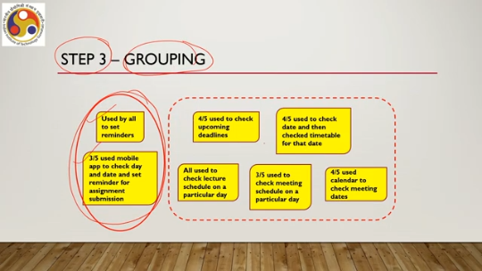
for each group. So, for these two, we can put a header reminder setting. For the remaining five, we can put a header work scheduling. So, if we are putting a header like that, then we can see that all these seven notes or seven ideas can be grouped into two groups. One is reminder related, one is scheduling related.
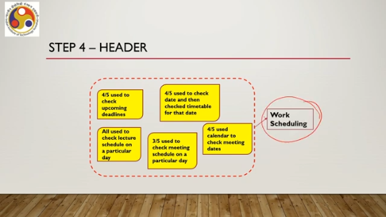
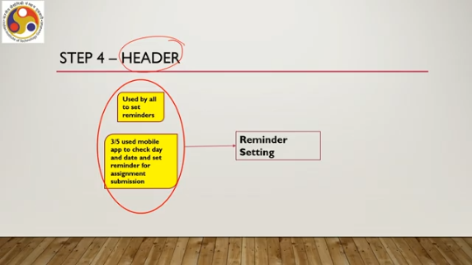
Now we can also have different ways to put headers depending on our analysis ability, our skills. So out of the five that we have put together and created one group heading, we can further divide them. One is overall scheduling. These two can come under this group and the other three these three can come under another group that is day-wise scheduling.
So, we can further refine the groups. So, instead of two, now we can have three groups. So, how does the finished diagram look? That is step five. One is reminder setting, then overall scheduling, finally day-wise scheduling.
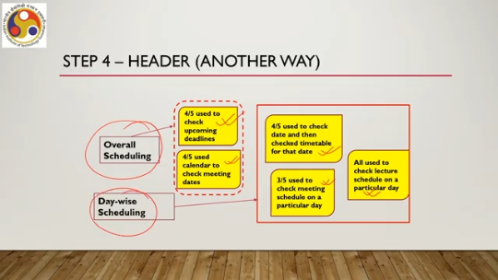
So, we have these three groups, one, 2 and 3. So, the observations are for all types of calendars used in the study: physical, mobile app, as well as desktop app. Some observations we can group in different ways. So, there are... this is possible; there is no unique way of grouping.
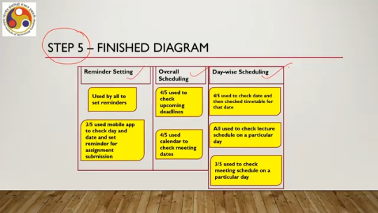
Now, this is what we can do with all the observations. Now, in the next part of the lecture, we will see with this type of reflection how we can convert this idea not only to guidelines but also to some specification that is amenable to implementation. So, we have come to the end of this part of the lecture. Here we talked about the basic idea of requirement gathering, CI, which is the CI. So far, whatever we have learned is
the basic idea of requirement gathering, also discussing contextual inquiry, a method for gathering. Now, this contextual inquiry: we have covered some ground on the basic idea, how it is used, and how to analyze the data. We will continue our discussion on data analysis and then subsequently how to use that data for system implementation in the subsequent part of the lecture. So, next we are going to cover how to use the data and also how we can relate the knowledge to the Majuli virtual tour. So, I hope you are able to follow this part of the lecture as well.
Looking forward to meeting you in the next part of this lecture on requirement gathering, where we will be covering more on how to use the data obtained through CI and also how this knowledge is used to build the Majuli virtual tour. So, looking forward to meeting you again in the next part of the lecture. Till then, goodbye. Thank you and happy learning.

